**Observation**

Inspection was undertaken at the subject property in the presence of Brett Robinson, representative of the Church to which the following was noted:

1. Images of the water damage within the new section of the church from the storm in February 2020 and July 2020 have been provided by Brett Robinson which have been attached as ***Appendix B*** and ***Appendix C*** respectively.
2. It is understood that Kase Building Group (KASE) were in the process of finishing off the reinstatement works for the damage caused by the February 2020 when water ingress reoccurred during the July 2020 storm.

## Points of Water Ingress

### New Section of Church – Southern Eastern Areas

1. Based on the provided images from the February 2020 and July 2020 storm we noted water damage within the following rooms of the new section of the Church:

* Store Room
* Cry Room
* Foyer
* South-eastern area of the Auditorium
* Recording room.

1. It was advised that KASE had dried the water ingress from the July 2020 storm in attempt to save building fabrics from being damaged.
2. At the time of our inspection we noted that most of the above-mentioned rooms were in a dry state with the exception of slight water ingress within the Store room. **Images 3 – 6**
3. From review of the Bureau of Meteorology weather data for Sydney Airport we note that approximately 55mm of rain fell between 8 – 10 August 2020, refer to ***Appendix D***.
4. During our inspection it was advised that in attempt to mitigate further water ingress from the rain experienced in the days prior to our inspection that builder’s plastic had been placed on the southern side of the church. **Image 7**

### Old Church – Northern Eastern Office

1. It has been advised that during the February 2020 and July 2020 storm that water ingress had been experienced within the North-Eastern office of the old church.
2. It was further advised that the smoke alarm had stopped working after the July 2020 storm due to water ingress and that the insulation within the ceiling cavity was also wet. **Image 8**
3. During our inspection we noted that the plasterboard ceiling lining was in a dry state and Brett Robinson also confirmed that the insulation within the ceiling cavity was also dry. **Image 9**
4. It was also advised that water ingress had been experienced with the Ground level kitchen about the North Eastern side of the church, however that remedial works had been undertaken and no water ingress has since been experienced within this area.

## Cause of Water Ingress

### New Section of Church – Southern Eastern Areas

1. Based on our internal inspection of the damaged areas of new church, it is evident that the water ingress has not occurred from the roof given no damage was observed to the ceiling linings.
2. In determining the cause of water ingress about the south-eastern areas of the new section of the church we have undertaken inspection of the southern elevation.
3. We note that the external area adjacent to the areas of water ingress are higher than the internal areas.
4. Brett Robinson advised that he understands that when the new section of the church was constructed that water ingress had been experienced and that remedial works had subsequently been undertaken to mitigate such water ingress.
5. From our external inspection we noted evidence of previous application of waterproofing consistent with previous attempt to mitigate water ingress. **Image 10**
6. With reference to typical waterproofing products, liquid applied waterproofing membranes typically have a lifespan of 10-15 years before progressive failures occur which such lifespan is consistent with the age of the building.
7. The recent water ingress within the subject building also indicates that previous waterproofing membrane application in mitigating water ingress had failed.
8. Furthermore, it is noted that the only damage caused by the rainfall in the days prior to our inspection was minor water ingress within the Store room.
9. As such, it is evident that the builder’s plastic installed on the southern elevation has reduced the amount of water ingress within the subject property. **Images 11 – 12**
10. We also observed water ingress within the wall cavity adjacent to the new section of the church to which we also note that the opening within the brickwork has been covered using FC sheet which has not been sealed around the edges. **Images 13 – 14**
11. Based on the provided advice and our observations about the areas of water ingress, in our opinion, the cause of water ingress is a result of the following:

* Failed waterproofing on the old section of the church which has allowed water to permeate through the brickwork and into the wall cavity and subsequently into the internal areas of the church.
* Omission/failed damp-proof course which allows water entrapped within the brick cavity to build up and subsequently permeate into the internal areas of the church.
* Insufficient seal around brickwork openings allowing water ingress into the wall cavity and subsequently into the internal areas.
* Failed waterproofing on the new section of the church allowing ground water to permeate through joins within the precast concrete panels and into the internal areas of the church.
* Water permeating through the join between the original brickwork and new precast panel due to insufficient seal. **Image 15**

1. In illustrating the above-mentioned cause of water ingress within the south-eastern area of the new church, we provide ***Figure 2*** below illustrating water permeating through the old church brickwork and ***Figure 3*** below illustrating water permeating through the new church precast concrete panels.

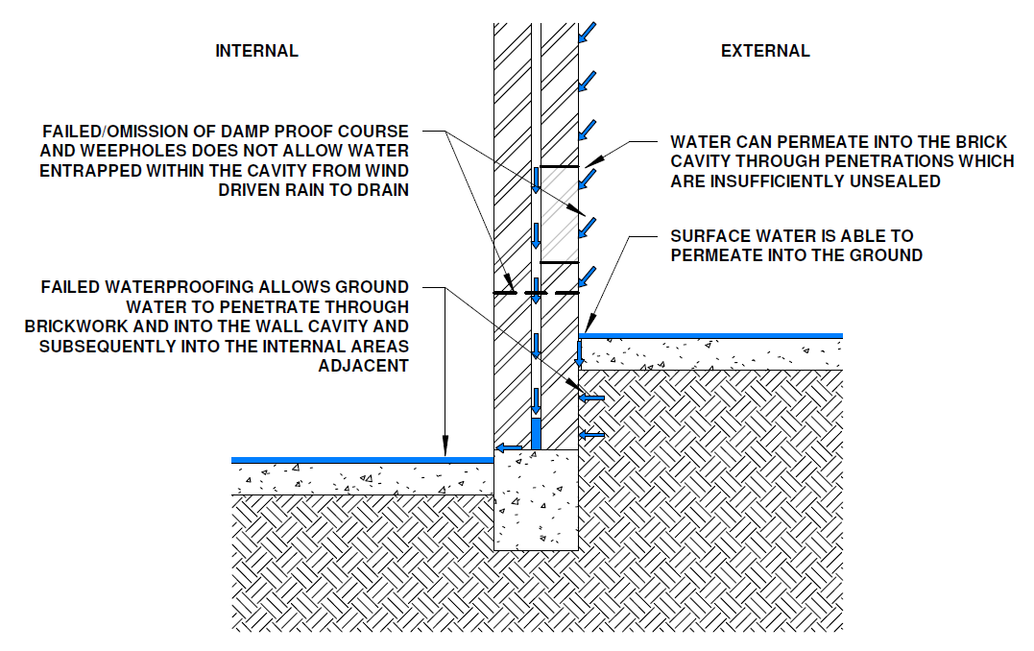

***Figure 2: Water Permeating into the Brick Wall Cavity Is Able to Subsequently Permeate into the Internal Areas***

*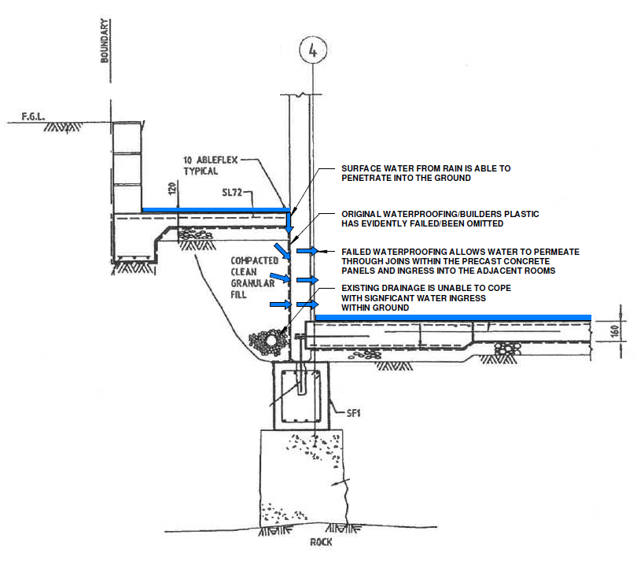****Figure 3: Failed/Omission of Waterproofing Allows Water to Permeate Through Joins Within the Precast Panels***

### Old Church – Northern Eastern Office

1. In determining the cause of water ingress within the north-eastern office of the old church we have undertaken inspection of the roof above the area of water ingress.
2. From our inspection of the roof above the north-eastern office, we noted the following issues:

* Apron flashing between the roof tiles and sheet metal roof has been downturned allowing water to ingress behind the flashing. **Images 16 – 17**
* Gaps within the FC sheet parapet below the roof tiles which have not been adequately sealed which allows water ingress during directional/wind driven rainfall. **Image 18**
* Unsealed gaps in parapet apron flashing which allows water ingress behind the flashing during directional and wind drive rainfall. **Image 19**
* Previous patch repair of join between the tiled roof and sheet metal roof using flexible waterproofing sheet indicating pre-existing issues with the join between the roof sheeting and tiled roof. **Image 20 – 21**
* Gap between the roof tiles and flashing at the top of the sheet metal roof allowing wind drive rain to penetrate below the roof tiles. **Image 21**
* Penetrations/Holes within the roof sheeting which has not been sealed which will allow water ingress below the roof sheeting. **Image 22**
* Cracking within the FC sheet parapet. **Image 23**
* Deteriorated flexible sealant with FC sheet parapet joints. **Image 24**
* Inadequately sealed penetrations through FC Sheet Parapet. **Image 25**
* Services within the roof sheeting with deteriorated flexible sealant around the services/penetrations, it is also noted that these services also obstruct water flow during rainfall. **Image 26**

1. Based on our inspection of the roof above the north-eastern office roof, it is evident that there are multiple points of water ingress which are outlined above.
2. We confirm that we did not observe any storm created opening within the roof above the North-Eastern office of the old church.
3. **As such, in our opinion, the cause of water ingress is a result of inherent building defects and long-term deterioration of sealant and sheeting, unrelated to any one-off or insurable event.**

## Whether ongoing drainage works to the exterior of the property has caused or contributed to water ingress from storm event 26 July;

1. It was advised at the time of our inspection that remedial works were taking placed about the southern side of the Church and that the area was exposed during the storm event on 26 July.
2. Based on the provided images and our observations, it is evident that water was able to more easily permeate into the ground due to the removal of sections of the slab on ground on the southern side of the property.
3. **In our opinion, the ongoing drainage works during the storm event on 26 July 2020 would have contributed to the water ingress, however was not the underlying cause of water ingress during the subject storm.**

## Provide recommended scope of work for any remedial repairs required and waterproofing/drainage rectification to avoid further water ingress in the future

1. In keeping inline with your instruction, we have prepared a separate remedial scope of works (***SWP-SoW-2001935***) to provide recommendations regarding mitigating further water ingress in the future.

**Discussion**

NA

**Conclusion**

## Points of Water Ingress and Cause of Water Ingress

### New Section of Church – Southern Eastern Areas

Based on the provided images from the February 2020 and July 2020 storm we noted water damage within the following rooms of the new section of the Church:

* Store Room
* Cry Room
* Foyer
* South-eastern area of the Auditorium
* Recording room.

Based on our observations about the areas of water ingress, in our opinion, the cause of water ingress is a result of the following:

* Failed waterproofing on the old section of the church which has allowed water to permeate through the brickwork and into the wall cavity and subsequently into the internal areas of the church.
* Omission/failed damp-proof course which allows water entrapped within the brick cavity to build up and subsequently permeate into the internal areas of the church.
* Insufficient seal around brickwork openings allowing water ingress into the wall cavity and subsequently into the internal areas.
* Failed waterproofing on the new section of the church allowing ground water to permeate through joins within the precast concrete panels and into the internal areas of the church.
* Water permeating through the join between the original brickwork and new precast panel due to insufficient seal.

### Old Church – Northern Eastern Office

It has been advised that during the February 2020 and July 2020 storm that water ingress had been experienced within the North-Eastern office of the old church.

Based on our observations of the roof above the North-Eastern office of the old church, we identified multiple locations where, in our opinion, water has been able to ingress into the subject area below which include the following:

* Insufficient apron flashing between tiles roof allowing water to penetrating behind the flashing.
* Deteriorated sealant and cracked FC sheet parapet cladding and inadequately sealed penetrations through the FC sheeting allowing water to penetrate through the FC sheeting.
* Gaps within apron flashing adjacent to the parapet flashing allowing water to penetrating behind the flashing during wind driven rain.
* Gaps between the roof tiles and sheet metal roof flashing allowing water to penetrating within the gap during wind driven rain.
* Unsealed holes within the roof sheeting allowing water to permeate below the roof sheeting.
* Deteriorated sealant around roof penetrations allowing water to ingress around the penetrations.

## Whether ongoing drainage works to the exterior of the property has caused or contributed to water ingress from storm event 26 July;

In our opinion, the ongoing drainage works during the storm event on 26 July 2020 would have contributed to the water ingress, however was not the underlying cause of water ingress during the subject storm.